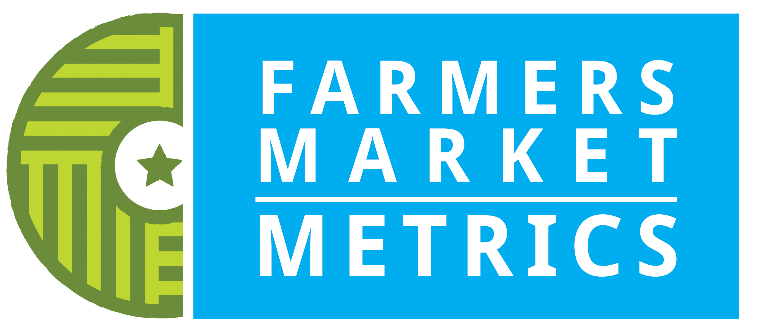

Unit 2
__________________________________________________________

metrics selection

Unit 2: Introduction

Figure 2.1 below presents the components of a complete evaluation system. For Farmers Market Metrics (Metrics), each component is being considered and resources developed for markets use. This graphic will be helpful for you to show to your market community when you begin to plan the evaluation season and to understand the many steps that have to be taken. As you can see, selecting metrics is part of a process that flows throughout your market’s evaluation project.

Figure 2.1. Cycle of Evaluation

2.2 Selecting Metrics
When choosing metrics, begin by examining the goals of your market or goals for a specific project.

In many cases, a market’s mission statement provides an outline with which to begin. Let’s say that your mission highlights supporting regional producers: in that case, selecting the metrics Average distance in miles traveled from farm to market and Total agricultural acres owned or managed by market vendors would be most helpful to measure the success of that goal.

Next, identify the audience(s) that will assist your market in meeting those goals. Most markets spend a great deal of their energy and time communicating with audiences that already support the market. While it is important to appreciate existing supporters, it is also essential to reach those who are ambivalent or unaware of the market in their community. A disciplined evaluation project speaks the same language to many audiences, no matter how much they already know about how markets work.

One way to assess whether your market is “preaching to the choir” is to consider how and where you communicate with your audiences. If Facebook and other social media sites are your chief avenues of communication, then your market is likely only updating current shoppers and existing stakeholders. If the market’s website is the main place news is shared, the market is sharing information primarily with strong supporters.

Both of those are a good use of management time, but what about new supporters who are less familiar with the history of the market or about farmers markets in general? What about funders that don’t normally fund food system work but are interested in tacking food insecurity and supporting farmers?

An in-depth market evaluation project will measure impacts on as many audiences as necessary, keeping in mind the time and effort it will take to collect and analyze that data. Choosing the right metrics for your market means first thinking about how many groups of unique audiences can be found within your market community: experienced vendors, regular shoppers, new shoppers, benefit program shoppers (i.e., SNAP or WIC recipients), Main Street business neighbors, and other populations. Once you have an idea of the audiences that need data on your market, you can sort through the Farmers Market Metrics to find those that work for distinct audiences.

Here’s an example of choosing a metric that will help guide a marketing strategy:

Market A wants to promote the number of products available on a single market day. By using data collected from vendors on their products with the metric number of different fruits and vegetable crops available for sale on the annual application, the market can advertise that list of produce when the spring season begins.

Here’s an example of choosing a metric related to sharing information with an identified audience:

Market B is embarking on a funding partnership with city public health agencies to add a cash incentive when visitors use their SNAP card. This project will collect data with two metrics: Number of SNAP transactions and Average number of SNAP-eligible goods per market day. If data is collected before and after the incentive is offered, those two metrics will show if there was any change in sales, and if sales vary based on how many products are at the market. Having that data available to share with the partner agencies will show the effects of the funding and may help support continuation of the program.

Connected to this training section, you’ll see an audience identification exercise in which you will identify individuals, organizations or communities that support the market; those who do not; and all of those in between.
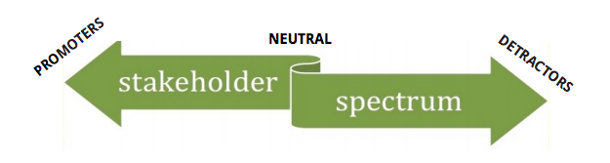

Exercise: Using the download available, have your team write down as many audiences that your market targets on a regular basis and put them on the graph where they belong. Stand back and look at the clusters and at the less populated areas of this spectrum and discuss extending your outreach to those audiences.

Audiences to consider include specific extension agents, new farmers, anchor vendors, area funders focused on education or ecological issues, print media, statewide farmers market leaders, at-risk residents, neighboring businesses, town leaders.

You’ll learn more about strategies for communicating data to different audiences in the Communications Guide.

2.3 Four Kinds of Capital
Capital represents the range of assets that contribute to wealth, encompassing the financial, ecological, social, individual, built, intellectual and political dimensions of a community or region. For Farmers Market Metrics, we focus on economic, ecological, social and intellectual benefits. These describe the type of benefit that the recipient receives directly or indirectly as a result of the market’s activities. The recipient can be a vendor, shopper, visitor, neighboring business or even extend to the surrounding region.

The capital framework has been used in evaluation systems such as the Ford Foundation’s efforts to measure rural communities and in Richard Florida’s work to measure creativity in cities. It has also been applied to markets in farmers market research conducted by Market Umbrella and in research by Projects for Public Spaces, among others. This type of framework works well to illustrate the multiple benefits that markets offer to their communities and is a recognizable format to present to market partners.

Areas of capital include:
- Economic capital identifies financial rewards, including job creation and built infrastructure.
- Intellectual (Human) capital includes acquiring knowledge, skills and capacity to make healthy/healthier choices.
- Social capital includes social inclusion, bridging and bonding, civic engagement and political participation.
- Ecological capital presents the conservation or reuse of natural materials, and the restoration and stewardship of the natural world.

A market may want to collect data across all four areas of capital and continue to collect the same metrics annually to show the multiple impacts that their market has on its community over time. This is a good strategy for collecting data to present in an annual report or fundraising letter.

2.4 Other Factors to Consider
How much time will it take?
When selecting which metrics to collect data for, consider the amount of time and staffing required to collect, enter, analyze and use the data.

Can the market use all of this data now?
Markets often think they must collect as many metrics as possible in a single data collection season in order for the collection process to be worthwhile. However, it is important to avoid survey burnout among market-goers or vendors. Additionally, the manager(s) may become overloaded if he or she needs to recruit too many volunteers. And good data can be used more than once, so do your best to select metrics sparingly and carefully.

In 2014, Farmers Market Coalition began work on a grant funded by USDA’s Agriculture and Food Research Institute in collaboration with the University of Wisconsin-Madison. Indicators for Impact: Farmers Markets as Leaders in Collaborative Food System Data Collection and Analysis was a three-year research project to identify and refine a set of metrics and data collection protocols in order to help market managers and organizers measure their contributions and impacts with their communities.

Read the following quotes from markets participating in the Indicators for Impact project as they describe their process for choosing metrics:

“To determine which metrics to collect, the board of directors and the market manager considered the information shared by the project leaders and then discussed what information would also be helpful in terms of long-term planning for our market. We also want to better understand who our customers are and where they come from.”

“We chose metrics that will be of interest to our stakeholders and Board of Directors, but will not take too much time for our market team.”

“We focused first on the things we could easily collect and then thought about the metrics that would be most useful for us in supporting and expanding the market operations (particularly in terms of getting resources for a regular market manager).”

“Our metric selection gives us the ability to show what fresh, local food are easily accessed at our market, how many people walk or bike to the market, and how the local economy is growing through farming, backyard farming and entrepreneurship.”

2.5 Key Takeaways
Choosing meaningful and appropriate metrics can provide valuable insight into the market’s operations and impact within the community. The metric selection process requires some reflection on the goals of the market or one of its projects, will help guide decision-making and program planning over time, and illustrate all the different ways the market adds value to the community.

Acknowledgements
These training materials were created with support from the United States Department of Agriculture’s (USDA) Farmers Market Promotion Program (FMPP) FL-326-G, and reference research in process as part of the USDA’s Agriculture and Food Research Initiative (AFRI) 2014-68006-21857, in collaboration with Dr. Alfonso Morales of the University of Wisconsin - Madison.

Created by Darlene Wolnik, with support from Sara Padilla, Jennifer Cheek, and Daniel Blaustein-Rejto and a panel of expert advisors, including Sharon Yeago.

